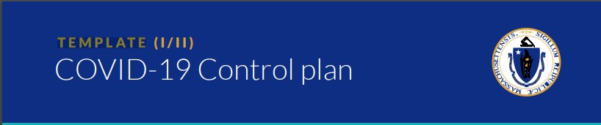

All businesses in the state of MA must develop a written control plan outlining how its workplace will comply with the mandatory safety standards for operation in the COVID-19 reopening period. This template may be filled out to meet that requirement. Control plans do not need to be submitted for approval but must be kept on premise and made available in the case of an inspection or outbreak.

All individually listed businesses must complete a control plan, even if the business is part of a larger corporation or entity.

BUSINESS INFORMATION: please provide the following information

Business Name: □ Check if part of a larger corporation

Address:

Contact Information (Owner/Manager):

Contact Information (HR representative), if applicable:

Number of workers on-site:

SOCIAL DISTANCING: check the boxes to certify that you have:

□ Ensured that all persons including employees, customers, and vendors remain at least six feet apart to the greatest extent possible, both inside and outside workplaces

□ Established protocols to ensure that employees can practice adequate social distancing

□ Posted signage for safe social distancing

□ Required face coverings or masks for all employees

□ Implemented additional procedures. Please describe them here:

HYGIENE PROTOCOLS: check the boxes to certify that you have:

□ Provided hand washing capabilities throughout the workplace

□ Ensured frequent hand washing by employees and provided adequate supplies to do so

□ Provided regular sanitization of high touch areas, such as workstations, equipment, screens, doorknobs, restrooms throughout work site

□ Implemented additional procedures. Please describe them here:

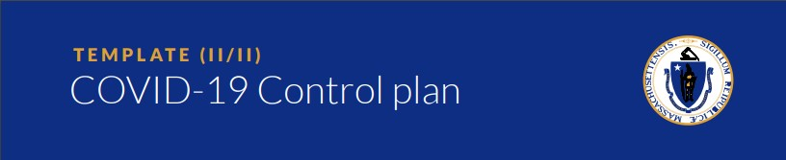

All businesses in the state of MA must develop a written control plan outlining how its workplace will comply with the mandatory safety standards for operation in the COVID-19 reopening period. This template may be filled out to meet that requirement. Control plans do not need to be submitted for approval but must be kept on premise and made available in the case of an inspection or outbreak.

All individually listed businesses must complete a control plan, even if the business is part of a larger corporation or entity.

STAFFING & OPERATIONS: check the boxes to certify that you have:

□ Provided training for employees regarding the social distancing and hygiene protocols

□ Ensured employees who are displaying COVID-19-like symptoms do not report to work

□ Established a plan for employees getting ill from COVID-19 at work, and a return-to-work plan

□ Implemented additional procedures. Please describe them here:

CLEANING & DISINFECTING: check the boxes to certify that you have:

□ Established and maintained cleaning protocols specific to the business

□ Ensured that when an active employee is diagnosed with COVID-19, cleaning and disinfecting is performed

□ Prepared to disinfect all common surfaces at intervals appropriate to said workplace

□ Implemented additional procedures. Please describe them here: ____________________________________________________________________________________________________________________________________________________________

